Figure 1. (A). Apparatus and dog in the starting position for the visible displacement test. (B). Apparatus and dog in the starting position for the 90° invisible displacement test.
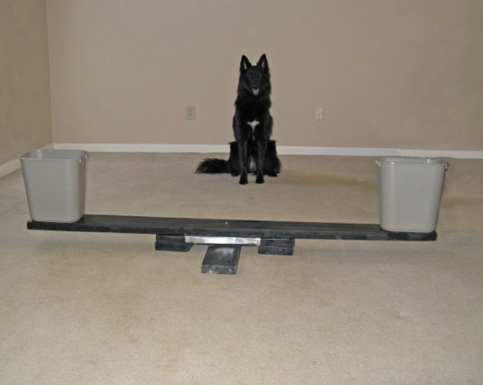
a.

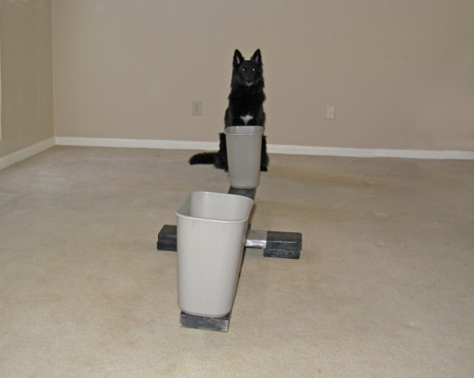
b.

Figure 2. A schematic representing the invisible displacement testing. The curtain was drawn open before the object was placed into an occluder and rotated into the final position. Once the object was invisibly displaced, the curtain was drawn closed for variable delays before being opened again. The dog was then allowed to search for the object.

Figure 3. Search accuracy on delayed invisible displacement testing as a function of self-control condition (Self-control vs. Control), drink (Glucose vs. Placebo) and delay.

