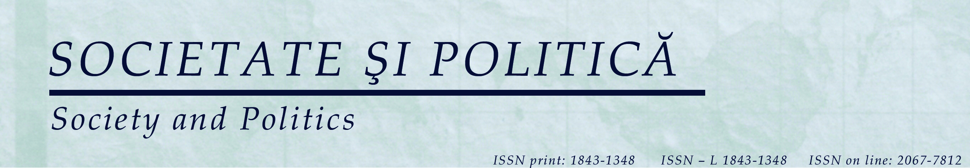

Arad,
July 11, 2017

Letter of allowance
To whom it may concern

This is to certify that Dr. Doina-Cristina Rusu may translate and republish (or use in whatever academic and lawful purposes she considers) her paper Abolishing the Borders between Natural History and Natural Magic. Francis Bacon’s Sylva sylvarum and The Historia vitae et mortis published in Societate și Politică (Society and Politics), vol 8, issue 2/16 (2014): 23-42.

Oana Matei,
Member of the editorial office Societate și Politică (Society and Politics)
Vasile Goldiş Western University of Arad
15 M.Eminescu str., 310086
Arad
oanamatei@yahoo.com

